**TSDS Key, Secret, and URL Assignment**

The following steps are for LEA personnel responsible for configuring the district’s Individual Operational Data Store (IODS) data permissions and security authorization within the Data Management Center (DMC) application. The **DMC LEA Technical** role is required and access to this process should be limited to one or two individuals only. LEAs must acquire a new Key and Secret each school year.

1. Log into **TEAL**.
2. 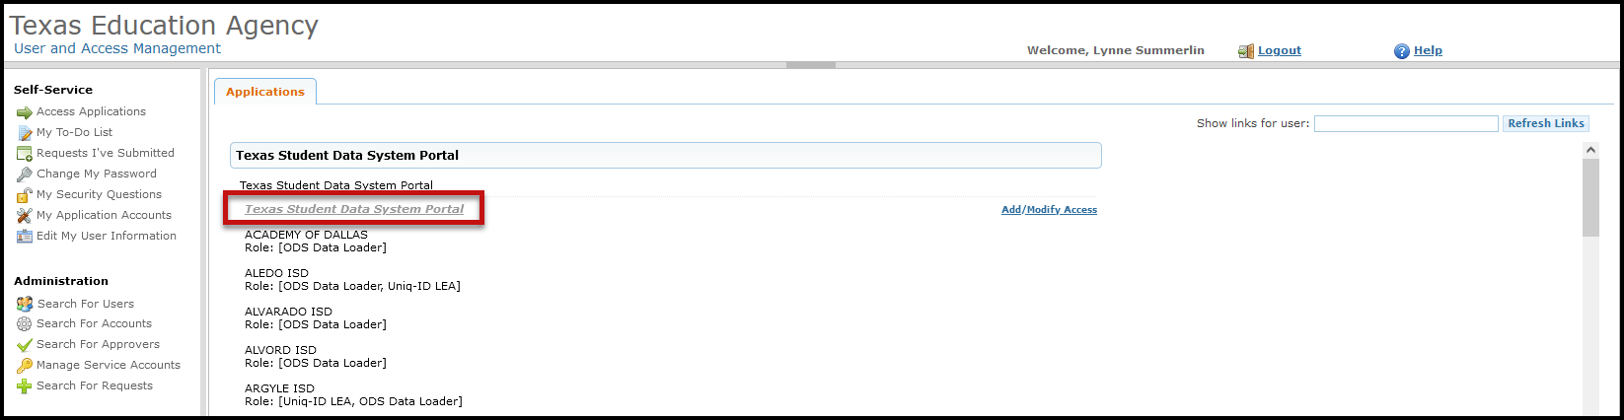Click on **Texas Student Data System Portal Parallel** link.
3. Click on **DMC** or **Manage IODS**.

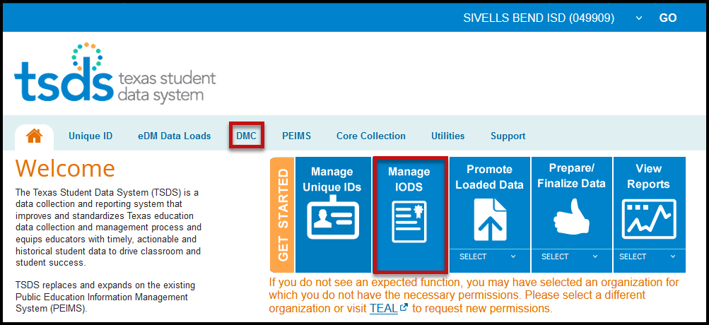

1. On the **Data Management Center (DMC)** screen select **Admin > Manage Application, Keys, and Secrets**.

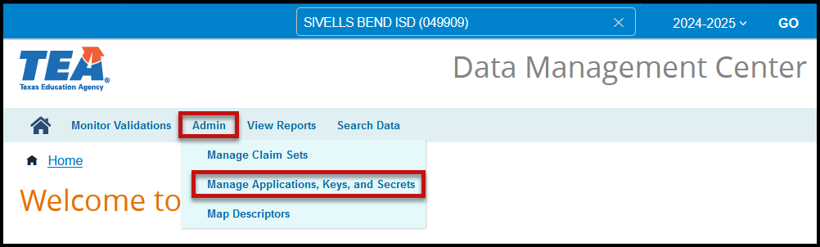

1. Select **Add Application**.

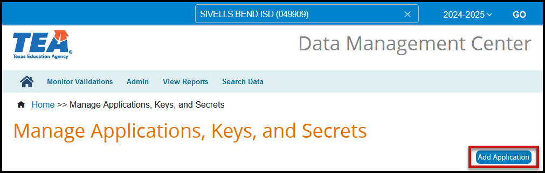

1. Enter an **Application Name**. It is suggested to enter the Vendor Name and Application (ASCENDER Student/Business).
2. 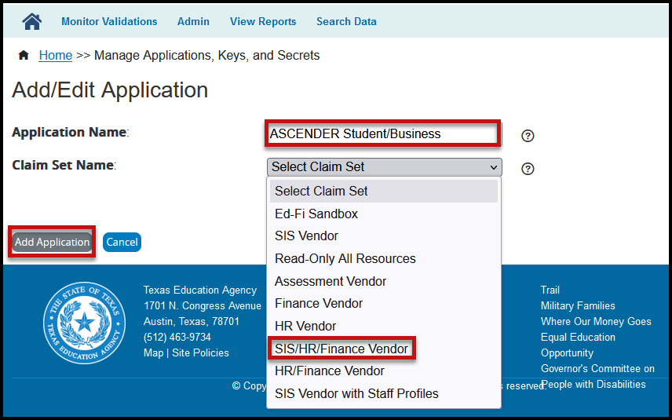Select the appropriate **Claim Set Name** from the pull-down menu. A separate Claim Set must be assigned if the district uses a different vendor for either student, finance, human resources, or assessments.

1. Click **Add Application**.
2. Click **Save** to save the application.
3. A **Key, Secret,** and **API URL** will be created. **Communicate the key, secret, and URL to the appropriate vendor or enter it into the appropriate area in your database(s).** **DO NOT** click **Acknowledged** until you have entered or communicated the information to the appropriate vendor!

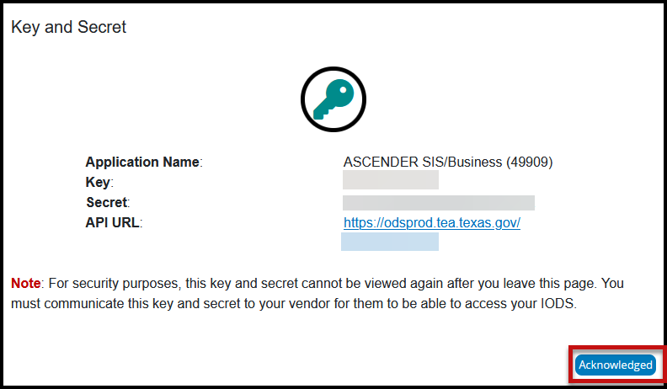

1. 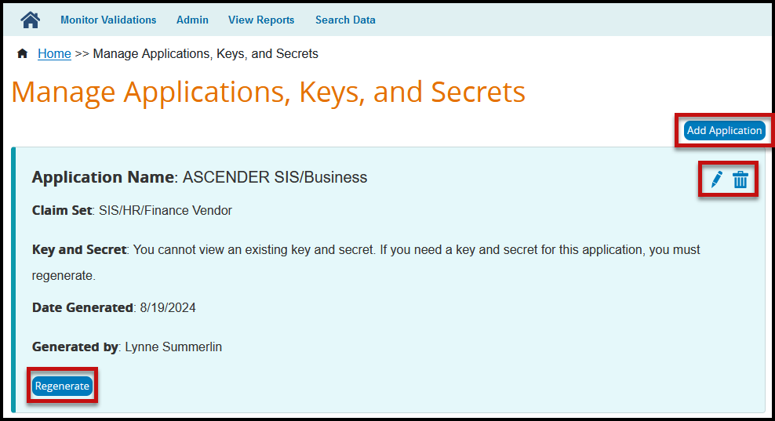Click **Acknowledged**.
2. Click **Add Application** to add applications for additional vendors.
3. Repeat the previous steps 6-11.
4. Use the **Regenerate** button if you need to create a new Key and Secret for some reason (the data is not flowing through the API to the IODS or the Acknowledge button was selected prior to communicating the information to the vendor).
5. To edit/update the application (change the claim set or rename the application) click the pencil icon.
6. To delete the application, click on the trashcan icon. Click **Delete Application** to delete the application or **Cancel** to cancel the delete request.

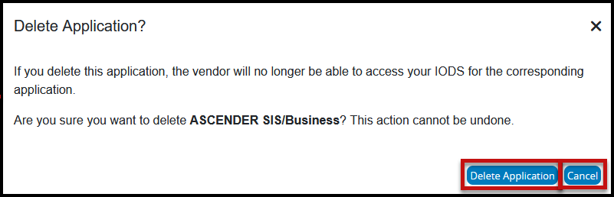

Limited Consent: ESC Region 11 grants permission to attendees of this session to reproduce and distribute designated resources and materials provided during the presentation.